**Ainthinai Arivom' Eco-Educational Camping Trip with ATREE's Agasthyamalai Community Conservation Centre (ACCC), Manimutharu**

**At Agastya Academy, we recently took our children on a camping trip, focusing on the exploration of the five types of lands. This camping trip evolved into a wholesome learning experience for all our students, thanks to a collaborative effort with the ATREE ACCC. In this blog, let’s see the highlights of the trip through the words of the children themselves.**

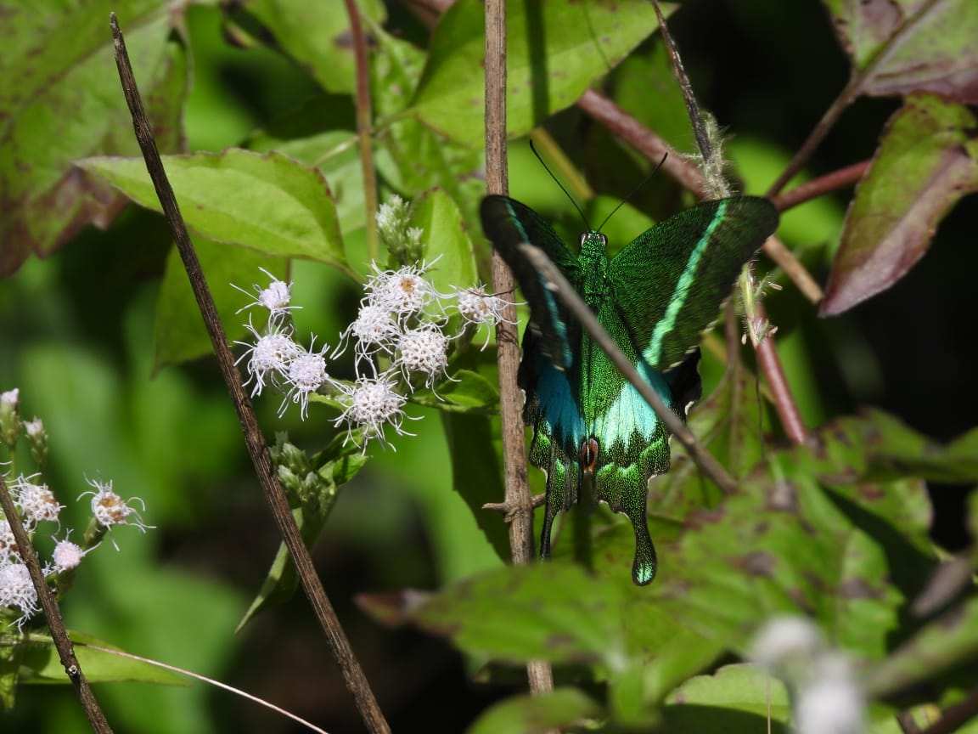**The mountain view behind the dormitory we stayed at was incredibly charming. The dormitory itself was well-organized, constructed with eco-friendly mud materials. We were delighted to be staying at a sustainable place and also receive delicious and timely meals.**

[Click here for read more..........](https://www.agastyaacademy.edu.in/post/ainthinai-arivom-eco-educational-camping-trip-atree-foundation)